- Noma 6920303/5 Mr & Mrs Gingerbread
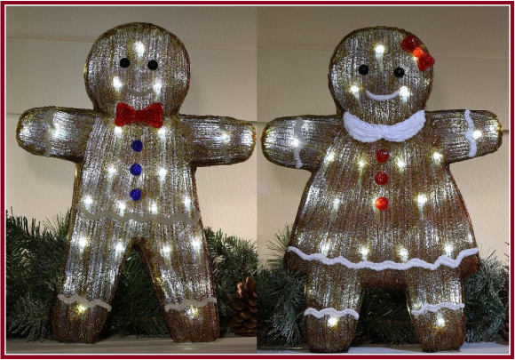
Everyone loves a Ginger!
Light up your Christmas inside and out with these great Mr & Mrs Gingerbread decorations from Noma (6920303/5), sold separately.
- Dimensions: L-30 cm x W-8.5 cm x H-40.5 cm.
- Acrylic
- 50 White LEDs
- 10m Lead cable
- Indoor/Outdoor
- Noma ‘Easy Timer’ function: 8 hrs On/16 hrs Off
- *** Transformer for indoor use only. ***

Price: €29 Each
- Noma 2514054 Sleigh & Two Reindeer
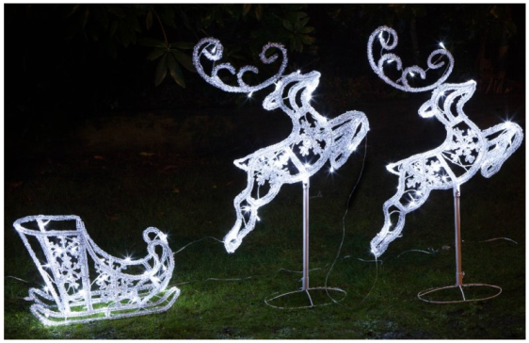
Start the countdown because Santa Claus is coming to town!

Stunning Christmas ‘flying' Sleigh with 2 Reindeer Set, featuring 150 white twinkling LEDs from Noma, featuring their Easy Timer technology.

- Spun Acrylic.
- Indoor/Outdoor.
- Height: 96cm.
- Lead wire length: 5m.
- 90 White LED’s.
- Noma ‘Easy Timer’ function: 8 hrs On/16 hrs Off.
- *** Transformer for indoor use only. ***

Price: €73

- Santa Snowman & Deer

Christmas isn't a season. It's a feeling.

Get in the Christmas spirit with some festive decorations from Hegarty Lighting.
Choose one of these three great characters for only €59 each.

- The blow mould Santa MER4LM (70cm) @ €59.
- The festive acrylic Deer CHLA-232 @ €59.
- The Snowman MER YLM-024 @ €59.

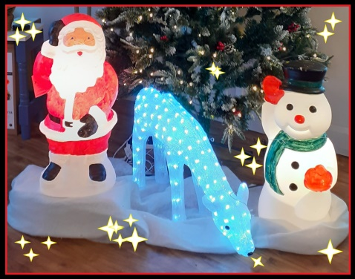

- Santa in Chimney MER YLM-025

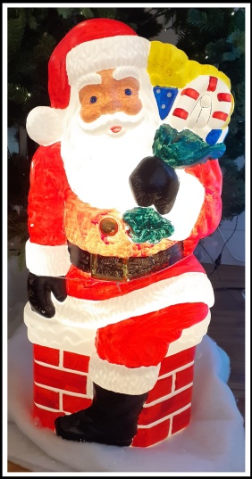

Dear Santa…
I’ve been good all year… most of the time… once in a while.
Never mind. I’ll buy my own stuff!

Santa in the Chimney/MER YLM-025 at Hegarty Lighting.
Price: €73

